1. Introduction and Overview
In the realm of communication, sign language serves as a critical medium allowing people who are hard of hearing or deaf to interact seamlessly with the world. Despite advancements in technology, there remains a significant barrier in translating sign language into text or speech in real-time, which limits the accessibility of various services and information for the deaf community. This project seeks to bridge this gap through the development of an advanced sign language recognition system that leverages deep learning techniques to accurately interpret sign language from video data.

1.1 Research Question
"How can deep learning models be effectively applied to real-time video to accurately recognize and translate sign language into text or spoken language?" This question addresses the need for a robust, efficient, and accurate system that can operate in real-time with high reliability, providing the deaf and hard of hearing community with a smooth means of communication.

1.2 Proposed System Design with Objectives
The proposed system is designed as a sophisticated deep learning model that processes video input to recognize sign language gestures and convert them into text. The system integrates several cutting-edge technologies including Long Short Term Memory (LSTMs) and convolutional neural networks (CNNs) specifically designed to manage the complexities of motion and gesture recognition in video sequences.

Objectives:
- Develop a high-accuracy model that can identify a various sign language sign from video inputs.
- Ensure real-time processing to allow for seamless communication without delays.
- Create a user-friendly interface that can be easily used by the deaf community and those who interact with them.
- Enhance model robustness to function accurately across different environments and lighting conditions.

1.3 Tools and Techniques for Investigation and Evaluation
This sign language recognition system will be developed and evaluated using a variety of instruments and methods, including:
- PyTorch and OpenCV: These libraries are utilized for constructing and training deep learning models and processing video data, respectively.
- Datasets: Training will involve curated datasets comprising video recordings of various sign language gestures. These datasets will be augmented using image and video processing techniques to increase model robustness.
- Model Evaluation: The model's performance will be evaluated based on its accuracy, speed, and reliability in translating sign language in real time. We'll compute common metrics like recall, precision, and F1-score.

1.4 Specific Deliverables
The project will result in several key deliverables:
- Software Application: A fully functional sign language recognition application.
- Documentation: Comprehensive documentation detailing system design, user guide, and developer notes.
- Training Models: Trained models ready for deployment and further customization.
- Evaluation Report: A detailed report on the performance evaluation of the system.

1.5 Ethical, Legal, Professional, and Social Considerations
Ethical and social considerations are paramount in the development of technologies that impact accessibility:
- Privacy and Consent: Ensure all video data used for training the model is obtained with consent and stored securely to protect individual privacy.
- Bias and Fairness: Actively work to minimize biases in the model, ensuring it performs equally well across different demographics within the deaf community.
- Accessibility: Commit to making the application easily accessible and user-friendly for all potential users, regardless of their technical proficiency.
- Compliance with ADA: Ensure the system complies with the Americans with Disabilities Act (ADA) by enhancing communication accessibility.

2. Progress to Date and Problem-Solving Strategies
For the development of advanced sign language recognition systems, our project has made significant strides in addressing the unique challenges of interpreting and translating American Sign Language from video inputs. Below we detail the progress made thus far, along with the strategies employed to tackle various challenges.

2.1 Literature Review and Technique Adaptation
Our literature review underscored the integration convolutional neural networks (CNNs) and Transformer blocks to enhance sign language recognition. Building on foundational studies, we adapted these models to suit the dynamic and varied nature of sign language gestures captured in video format.
Convolutional Neural Networks (CNNs) in SLR: CNNs have revolutionized the field of image processing by excelling in spatial feature extraction. The work of Yuan et al. (2020) demonstrated the efficacy of CNNs in hand gesture recognition with wearable sensors, achieving impressive accuracy rates (Yuan et al., 2020)[1]. Similarly, Al-Hammadi et al. (2020) utilized Single and Parallel 3D CNNs to effectively interpret hand gestures across various datasets, noting the challenge of hyperparameter selection in such complex models (Al-Hammadi et al., 2020)[2].
Recurrent Neural Networks (RNNs) and their Variants: The temporal dynamics of sign language necessitate models that understand sequential data, where RNNs and their variants like LSTM play a crucial role. Lee et al. (2021) employed an LSTM-enhanced K-Nearest Neighbor method for real-time SL recognition, showcasing high accuracy albeit with a limitation to one-handed signs (Lee et al., 2021)[3]. The integration of temporal layers allows for the modeling of gesture sequences, providing a deeper understanding of sign language flows.
Attention Mechanisms in Video and Sequence Processing: The introduction of attention mechanisms has marked a significant evolution in computer vision as well as natural language processing. These mechanisms enhance the interpretability and efficiency of neural networks by allowing models to concentrate on pertinent portions of the input data. Notable implementations in video processing have shown promise in tasks requiring detailed focus on specific regions or frames within video sequences (Vaswani et al., 2017)[4]. Our approach draws on these insights to refine SLR by focusing the model's computational resources on the most informative segments of sign language videos.
Integration of CNNs and RNNs: While CNNs and RNNs are powerful in their respective domains of spatial and temporal processing, their integration has been explored to a lesser extent in SLR systems. The hybrid models proposed in recent studies have begun addressing this gap, offering frameworks that harness both spatial and temporal data effectively (Gupta and Kumar, 2020)[5]. This integrated approach forms the backbone of our methodology, aiming to capture the comprehensive essence of sign language gestures.

2.2 Dataset Acquisition and Preparation
Our work utilizes the WLASL dataset, a comprehensive collection of Word-Level American Sign Language videos. This dataset is best for training deep learning models due to its extensive vocabulary and a range of signers, which introduces a level of complexity and variation that models must handle to be effective in real-world applications. We have used 300 unique classes of WLASL dataset.
The preprocessing of the WLASL dataset is a critical step in preparing the input data for the custom model. Given the variability in video quality and the nuances of sign language gestures, several preprocessing steps are taken:
- Video Frame Extraction: Each video is processed to extract frames, which are the individual images that make up the video. These frames are then used as the input data for the model. This step is crucial because the custom model, like other deep learning models, learns from these frames to recognize patterns associated with different signs.
- Resizing and Normalization: To guarantee consistency in the size of the input data, all video frames are resized to a standard size., which is necessary for the model to process them efficiently. Additionally, the frames are normalized, which involves adjusting the pixel values so that they have a similar distribution. This normalization facilitates accelerated learning and enhances the performance of the model.
- Data Augmentation: To make the model robust to various real-world conditions, distinct type of data augmentation methods like random flipping and cropping are applied. These techniques help simulate different viewing angles and distances, building the model more flexible and less likely to overfit to the training data.
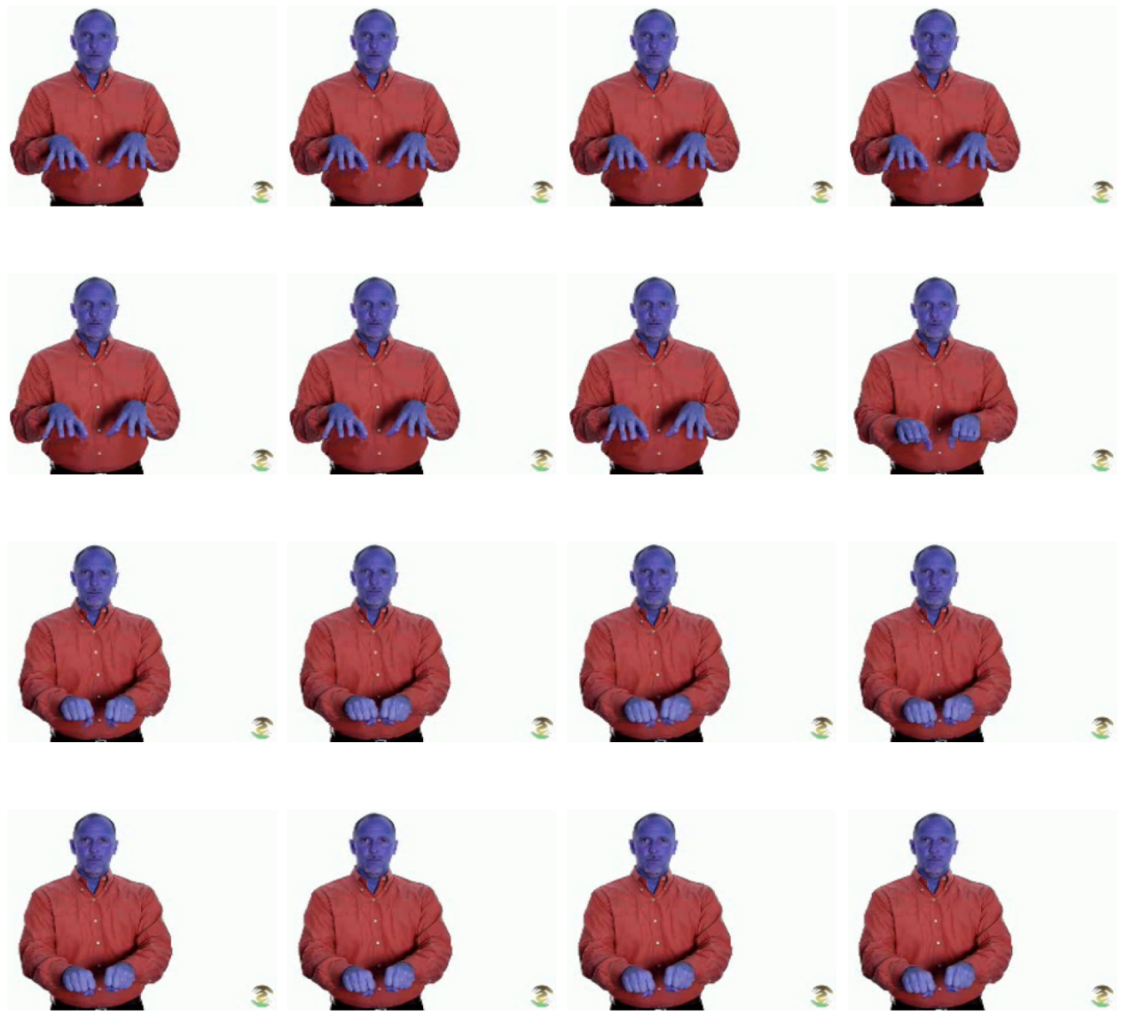
Figure 1 Preprocessed Video Frames

2.3 Feature Extraction
The feature extraction process in our project utilizes a combination of advanced image processing techniques to prepare video data for training the deep learning model. This phase is crucial for translating raw video into a format that the neural network can effectively learn from. Using the GroupTransform and BaseTransform classes, we perform several transformations on the video frames:
- Resizing and Cropping: Frames are resized and cropped to ensure uniformity, which helps in standardizing input data for the model.
- Color Adjustments: Adjustments such as changing brightness, contrast, saturation, and hue help the model become robust to variations in video quality and lighting conditions.
- Normalization and Conversion: Frames are normalized to balance pixel values, making the model training faster and more stable. The conversion of frames from BGR to RGB format aligns with the model's expectations for color channel ordering.
These transformations not only enhance the quality of the training data but also introduce necessary variations that help in generalizing the model’s performance across different environments and conditions.

2.4 Model Development
The development of the model is centered around a Custom Resnet+LSTM architecture, designed specifically to handle the complexities of video-based sign language recognition. This sophisticated framework is tailored to extract rich features from both individual frames and sequences of frames, providing a deep understanding of dynamic sign language movements.

2.5 Training the Model
Training the model involves several steps optimized to enhance its learning efficiency and accuracy:
- Data Splitting: Video data is divided into training and validation sets to ensure that the model can be evaluated on unseen data, promoting its ability to generalize.
- Optimization Techniques: Utilizing optimizers like Stochastic Gradient Descent (SGD), the training process is carefully managed to minimize errors in gesture recognition.
- Loss Function: To address class imbalance, a focal loss function is used, which increases the concentrate on instances that are more challenging to categorize, which is critical for datasets with a wide variety of sign gestures.
- Iterative Training and Validation: The model undergoes multiple epochs of training, with intermittent evaluations to monitor progress and adjust parameters accordingly.
The systematic and iterative approach to training ensures that the model not only learns effectively but also adapts to the intricacies of sign language recognition.

2.6 Problems Encountered and Steps Taken to Solve Them
Throughout the development process, several challenges were encountered:
- Class Imbalance: The diverse range of signs in the WLASL dataset resulted in some classes being underrepresented. The focal loss function helped in mitigating this by weighting the loss contributed by rare classes more heavily.
- Overfitting: At first, the model did remarkably well with training data but badly with validation data. This issue was addressed by introducing dropout layers within the transformer blocks, which randomly ignore certain neurons during training, thus helping the model generalize better.
- Computational Constraints: The initial model architecture required substantial computational resources, which was mitigated by optimizing the model’s layer configurations and employing more efficient data loaders.

3. Results
Our Resnet+LSTM model achieved 71% Validation accuracy on 300 classes
Here are training and validation Loss and Accuracy Curves:

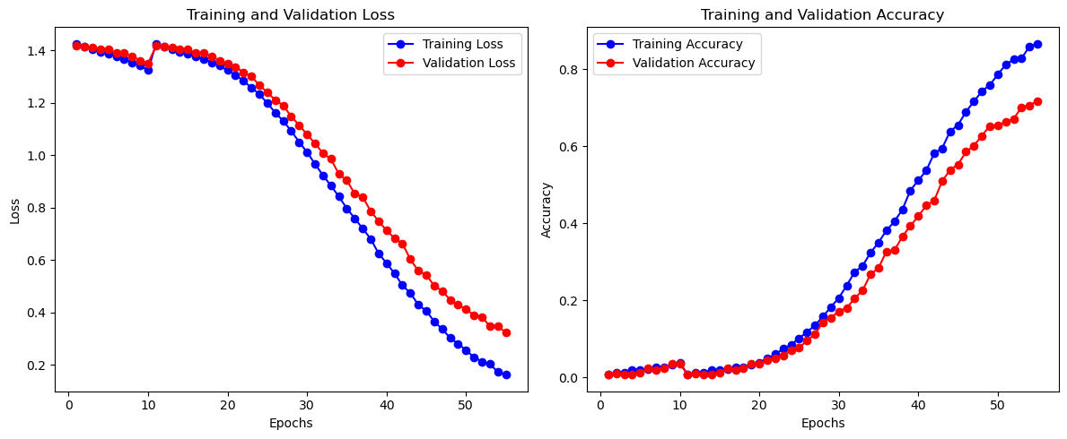

‬‬‬

4. References‬‬‬
[1] Yuan, G., Liu, X., Yan, Q., Qiao, S., Wang, Z., & Yuan, L. (2020). Hand gesture recognition using deep feature fusion network based on wearable sensors. IEEE Sensors Journal, 21(1), 539–547.
[2] Al-Hammadi, M., Muhammad, G., Abdul, W., Alsulaiman, M., Bencherif, M. A., & Mekhtiche, M. A. (2020). Hand gesture recognition for sign language using 3D CNN. IEEE Access, 8, 79491–79509.
[3] Lee, C. K., Ng, K. K., Chen, C.-H., Lau, H. C., Chung, S., & Tsoi, T. (2021). American sign language recognition and training method with recurrent neural network. Expert Systems with Applications, 167, 114403.
[4] Vaswani, A., Shazeer, N., Parmar, N., Uszkoreit, J., Jones, L., Gomez, A. N., Kaiser, Ł., & Polosukhin, I. (2017). Attention is all you need. Advances in neural information processing systems, 30.
[5] Gupta, R., & Kumar, A. (2020). Indian sign language recognition using wearable sensors and multi-label classification. Computers & Electrical Engineering, 106898.

